**Generating Buy-In**

**By ProVision Advisors**

Buy-in is central to being effective as an advisor or in leading up and down your organization. You need your audience or team to be aligned behind leadership and in concert with their efforts to achieve a desired end state. Trusting your teammates and wanting to follow guidance and direction doesn't happen by accident…whether on the bridge of warship, in the huddle as the quarterback calls what could be the game winning play or in the boardroom providing advice to a CEO who is managing a crisis. As most realize, assigned positions and roles will only get you so far. In order to meet the mission, to win or to see a crisis through successfully, impact players must have the faith and confidence of their teammates.

Building on writing and incorporating lessons from our own experience advising senior leaders and leading teams, we think of buy-in in the following context:

**As a trait—**High-performing organizations have the following in common:

* Trust and confidence in the leadership and in the direction of the organization.
* Proficiency and competency. In short…people are good at their jobs.
* **Buy-in** among the team. Everyone *believes*in the mission and the direction they are going.

**As something you build –** Selfless leadership and effective communication are the building blocks…the foundation…for establishing the environment for buy-in.

**A) Start with Why**

Simon Sinek authored the book “Start with Why,” and in that book he asks - Why are some people and organizations more innovative, more influential, and more profitable than others? Why do some command greater loyalty?

The answer is this: It starts with WHY. What is the “Why” of your organization? WHY do we need your position…your department…your input?

The more people understand why they are doing something, the more they will get behind it. “Clean you’re room….because I said so” may work on a child who is raised and taught to respect and even fear authority might work for a while, but with adults and professionals  the “We’re doing this because the boss said so” will absolutely not work.

In Sinek’s book, he talks about the Golden Circle. The neuroscience behind the Golden Circle idea is that humans respond best when messages communicate with those parts of their brain that control emotions, behavior and decision-making. And thus, they want to know why and how before they are tasked with the what.

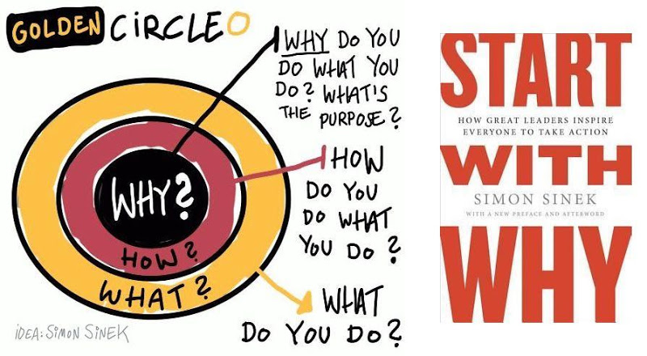

**B) Frame and scope problems and tasks in a logical way...make clear how tasks or needs fit together.**

As veterans we think in terms of missions, functions and tasks...but similar corporate or small business rubrics work just as well.

**Mission** – The overall mission...either short-term in a crisis, or long-term in a transformational effort.  The mission is where the WHY comes from.

**Functions** – What is the function of your job and the jobs of those around you?

**Tasks** – What tasks are individual or combined. Is there a grey-area? Are there redundancies? How do you do deconflict?  Make sure everyone has a role to play…and they feel valued in that role.

Consistency in how you think, talk about and task builds credibility and trust.

**C) It's a process...that needs to be repeated.**

**Buy-in Process:**

1. Identify your stakeholders-who is the audience?
2. Identify Stakeholder needs--what do they need to hear? How do they want to hear it?
3. Engage Head, Hearts and then Hands…connect to purpose and goals before tasking*.*
4. Senior Management…keep them informed, no surprises…don’t be afraid to ask for help and reinforcement…not just accountability.
5. Measure…together set clear way points that the entire team understands and gages progress from.

Hopefully this brief overview resonates with how you and your organization think about leading and communicating. In our communication coaching we use this baseline of building and maintaining buy-in as the starting point for lessons on strategic and tactical communication. To learn more, please reach out...we can help you and your team achieve success.